PROJECT REPORT
India's Agricultural Crop Production Analysis
A Tableau-Based Business Intelligence Dashboard Project
Project Title | India's Agricultural Crop Production Analysis
Domain | Agriculture / Data Analytics & Business Intelligence
Tool | Tableau Desktop / Tableau Public
Dataset | Historical Indian Crop Production Data, 1997–2021
Prepared By | Divya Kauluri (Team Project — completed individually; the team lead and other assigned members did not contribute to the work)
Mentor | N/A — Individual Submission
GitHub Repository | https://github.com/divyakauluri-spec/India-s-agricultural-crop-production-analysis
Tableau Public Link | https://public.tableau.com/app/profile/divya.kauluri/viz/IndiaAgricultureanalysisproject/IndiasAgricultureJourney?publish=yes
Date | 20/07/2026

Project Context
This report presents a comprehensive visual exploration of India’s agricultural cultivation using 25 years (1997–2021) of historical crop production data. Nine Tableau visualizations — a KPI Summary panel, State-wise Production Map, Year-wise Total Production chart, Trend of Agricultural Yield chart, Cultivated Area by Crop chart, State-wise Cultivated Area Comparison chart, Leading States by Production chart, Production Distribution by Unit Type donut, and Season-wise Production pie — are combined into four role-specific dashboards and a five-point guided Story, enabling stakeholders to uncover patterns, identify areas of growth or concern, and make data-driven decisions.
By harnessing the power of Tableau, this report presents the data in a visually appealing, interactive form that lets readers explore the intricacies of India’s agricultural cultivation for themselves.

Scenario 1: Small-Scale Farmer
Rajesh is a small-scale farmer in Uttar Pradesh who wants to maximize his crop yield and income. However, he struggles to decide which crops to grow each season due to changing weather patterns and market demand. By analyzing historical agricultural data (1997–2021), Rajesh needs insights into seasonal crop trends, regional productivity, and high-performing crops to make better farming decisions and reduce risk. The Farmer’s View dashboard serves Rajesh through the Cultivated Area by Crop and Season-wise Production charts.

Scenario 2: Government Policy Analyst
Ananya works with the Ministry of Agriculture and is responsible for designing policies to improve agricultural productivity across India. She needs to identify regions with low crop yield, understand long-term production trends, and evaluate the impact of seasonal variations. Using Tableau dashboards, she aims to uncover patterns in the data to support data-driven policy decisions and allocate resources effectively. The Policy Analyst’s View dashboard serves Ananya through the State-wise Production Map and Trend of Agricultural Yield chart.

Scenario 3: Agribusiness Investor
Vikram is an agribusiness investor looking to invest in high-growth agricultural sectors. He needs to analyze historical crop production data to identify profitable crops, emerging trends, and regions with consistent growth. By leveraging visual analytics in Tableau, Vikram seeks to minimize investment risk and make informed decisions on where and what to invest in the agricultural market. The Investor’s View dashboard serves Vikram through the Leading States by Production and Cultivated Area by Crop charts.

Contents
- Introduction
  - Project Overview
  - Purpose
- Ideation Phase
  - Problem Statement
  - Empathy Map Canvas
  - Brainstorming
- Requirement Analysis
  - Customer Journey Map
  - Solution Requirement
  - Data Flow Diagram
  - Technology Stack
- Project Design
  - Problem – Solution Fit
  - Proposed Solution
  - Solution Architecture
- Project Planning & Scheduling
  - Project Planning
- Functional and Performance Testing
  - Performance Testing
- Results
  - Output Screenshots
- Advantages & Disadvantages
- Conclusion
- Future Scope
- Appendix

Introduction

Project Overview
India's Agricultural Crop Production Analysis is an individually completed Tableau business intelligence project built on
25 years (1997–2021) of historical Indian government crop production data, spanning 36 states/union territories and 57 crop types. The raw government extract of 345,407 records was cleaned and enriched in Python (Pandas) before being connected to Tableau Desktop, where nine worksheets, four role-specific dashboards, and a five-point guided Story were built and published to Tableau Public for free, browser-based, authentication-free access.
Although originally assigned as a team project, the dataset cleaning, all Tableau development, documentation, and testing described in this report were completed individually by Divya Kauluri; the team lead and other assigned members did not contribute to the work.

Purpose
The purpose of this project is to turn a large, unfiltered government dataset into an accessible decision-support tool for three distinct audiences: small-scale farmers choosing what to plant each season, government policy analysts targeting resource allocation to low-yield regions, and agribusiness investors screening states and crops for growth opportunities. Each audience is served by a purpose-built dashboard view rather than a single generic report, with a guided Tableau Story tying the three perspectives together into one narrative.

Ideation Phase

Problem Statement
Problem statements were derived from two primary personas using an "I am / I'm trying to / But / Because / Which makes me feel" framework.
Field | Persona 1 — Rajesh (Farmer) | Persona 2 — Ananya (Policy Analyst)
I am (Customer) | A small-scale farmer in Uttar Pradesh with limited access to agricultural data | A government policy analyst at the Ministry of Agriculture responsible for policy design
I'm trying to… | Decide which crops to grow each season to maximize yield and income | Identify regions with low crop yield and understand long-term production trends to allocate resources
But… | I don't have access to historical crop performance data for my region or season | Data is fragmented across departments and not visualized in a way that supports quick policy decisions
Because… | Agricultural data is complex, scattered across government reports, and not presented visually | Government datasets lack interactive visualization tools that allow drill-down by state, season, and year
Which makes me feel… | Anxious, uncertain about my income, and forced to rely on guesswork and tradition | Frustrated and unable to confidently justify resource allocation decisions with data evidence

Key Takeaway
Both personas are blocked by the same root cause: agricultural data exists but is not accessible or visual. This shared root cause justified a single Tableau solution serving both audiences (and, by extension, Vikram the investor) rather than three separate tools — one shared data model with role-specific dashboards layered on top.

Empathy Map Canvas
The empathy map below was built for Rajesh, the small-scale farmer, whose constraints (limited data literacy, singleregion focus) are the most restrictive of the three personas, making him the priority case for the initial design.
Dimension | Content
SAYS | "I always plant what my father planted." / "I wish I knew which crops grow best near my district." / "The market price changes every season and I never know what to expect."
THINKS | "Which crop will give me the best return this Kharif season?" / "Is the weather pattern changing how my region performs?" / "Am I missing out on more profitable crops that others are growing?"
DOES | Relies on word-of-mouth advice from neighboring farmers; follows traditional cropping calendars; makes decisions based on limited local observation
FEELS | Anxious about unpredictable yields; frustrated by lack of reliable, region-specific data; hopeful that technology could help reduce financial risk
PAINS | No access to historical, region-specific crop performance data; cannot compare seasonal outcomes across years; limited ability to visualize trends
GAINS (What Success Looks Like) | Clear visual insight into which crops perform best in his state and season; confidence in crop selection decisions; reduced financial risk
The pains-to-gains mapping shaped two concrete design decisions carried into the final workbook: the Farmer's View dashboard intentionally uses only three charts (Season-wise Production, Trend of Agricultural Yield, Cultivated Area by Crop) to avoid overwhelming a first-time user, and every chart uses plain axis labels rather than technical field names.

Brainstorming, Idea Generation & Prioritization

Step 1 — Problem Selection
Selected problem: "How can I empower farmers, policy analysts, and investors to make data-driven agricultural decisions using historical production data from 1997–2021?"

Step 2 — Idea Listing
- Build state-wise and district-wise production maps to show regional variation
- Create seasonal trend charts (Kharif vs Rabi vs Whole Year vs others)
- Develop year-over-year line charts to show production growth or decline
- Build crop-wise treemaps to show relative crop importance by volume
- Design role-specific dashboards for the Farmer, Policy Analyst, and Investor personas
- Combine all dashboards into a Tableau Story for narrative-driven presentation
- Publish to Tableau Public for free, browser-accessible sharing

Step 3 — Idea Prioritization

Idea | Impact | Feasibility | Priority
State-wise production map | High | High | 1
Year-wise trend line chart | High | High | 2
Top 10 crops bar chart | High | High | 3
Season-wise distribution chart | Medium | High | 4
Crop-wise treemap | Medium | High | 5
Role-specific dashboards (3) | High | Medium | 6
Tableau Story (narrative) | Medium | Medium | 7
Publish to Tableau Public | High | High | 8

Requirement Analysis

Customer Journey Map — Rajesh (Small-Scale Farmer)
Stage | Awareness | Consideration | Onboarding | Usage | Decision
Actions | Realizes crop yields have been inconsistent for several years | Hears about a data dashboard showing crop trends for his region | Opens the Tableau Public dashboard for the first time via a shared link | Filters by state, season, and explores crop production charts | Selects a crop for next season based on 20+  years of historical  data
Emotions | Frustrated, uncertain | Curious, slightly skeptical | Overwhelmed, then reassured | Engaged, empowered | Confident, relieved
Touchpoints | Local farmer network, news, NGO outreach | Government  extension officer recommendation | Tableau Public  dashboard (shared link) | Interactive filters:  State, Season,  Crop, Year slider | Final crop and season decision informed by data
The emotional curve dips lowest at Onboarding, then climbs as filters let Rajesh narrow the view to something personally relevant — confirming that usability and guided onboarding are the difference between abandonment and a confident planting decision. Two requirements below were added directly from this map: persistent filter state across dashboard tabs, and a sub-3-second filter response target.

Solution Requirement

Functional Requirements
FR # | Requirement | Description
FR-01 | Data Connectivity | System shall connect to the cleaned crop production CSV dataset (345,407 rows, 1997–2021)
FR-02 | State/Region Filter | System shall allow users to filter all visualizations by State Name
FR-03 | Season Filter | System shall allow multi-select filtering by Season (Kharif, Rabi, Whole Year, Autumn, Summer, Winter)
FR-04 | Year Range Filter | System shall provide a slider filter for Crop Year Numeric (1997–2021)
FR-05 | Crop Filter | System shall allow filtering by individual crop types (57 unique crops)
FR-06 | State-wise Production Map | System shall display a filled geographic map of India colored by SUM(Production) per state
FR-07 | Year-wise Trend Chart | System shall display a line chart showing total national production by year (1997–2021)
FR-08 | Top 10 Crops Chart | System shall display a ranked horizontal bar chart of top 10 crops by total production
FR-09 | Season-wise Chart | System shall display a bar chart comparing total production across all 6 seasons
FR-10 | Crop-wise Treemap | System shall display a treemap of crop production, sized by SUM(Production)
FR-11 | Role-Based Dashboards | System shall combine charts into dashboards: Farmer, Policy Analyst,
FR # | Requirement | Description
 |  | and Investor views
FR-12 | Tableau Story | System shall present a guided narrative Story with story points, one per persona
FR-13 | Tableau Public Publishing | System shall be published to Tableau Public for browser-based access without login
FR-14 | Tooltip on Hover | All charts shall display State Name and Production value on hover
Every functional requirement above was verified against the shipped workbook during Performance Testing (Section 6). The only change from the original plan was an increase in worksheet count from five to nine charts, once it became clear a Production Distribution by Unit Type chart was needed to correctly interpret rankings distorted by mixed Tonnes/Bales/Nuts units. Non-Functional Requirements
NFR # | Category | Requirement
NFR-01 | Usability | Dashboard UI shall be navigable by non-technical users (farmers, policy makers) without training
NFR-02 | Performance | All filters shall respond and re-render within 3 seconds on the full 345K row dataset
NFR-03 | Reliability | Published Tableau Public workbook shall be available 99%+ of the time via public URL
NFR-04 | Scalability | Solution architecture shall support addition of new years' data without redesigning dashboards
NFR-05 | Availability | Dashboard shall be accessible via standard web browsers (Chrome, Edge, Safari) without plugins
NFR-06 | Security | No personally identifiable information (PII) is stored or displayed; dataset is fully public
NFR-07 | Maintainability | Workbook shall be saved as .twbx (packaged workbook) with embedded data for portability
NFR-08 | Compatibility | Solution shall render correctly on desktop (1366×768 or higher) and Tableau Public mobile view

Data Flow Diagram
The end-to-end data flow for this project:
- Step 1 — Raw Source: Historical crop production data in Excel/CSV format (345,407 rows, 1997–2021)
- Step 2 — Data Cleaning & Preprocessing: Python (Pandas) used to rename columns, strip whitespace, extract numeric year from 'YYYY-YY' format, add Yield = Production/Area, remove nulls
- Step 3 — Cleaned Dataset: skillwallet_crop_cleaned.csv (345,407 rows, 12 columns) loaded into Tableau
- Step 4 — Tableau Data Source: CSV connected as a Text File source; State Name assigned Geographic Role = State/Province
- Step 5 — Visualization Layer: nine chart sheets built (KPI panel, map, line, bar charts, treemap-style views, donut, pie)
- Step 6 — Dashboard Layer: four dashboards assembled from chart sheets with interactive filters
- Step 7 — Story Layer: five-point Tableau Story combining dashboards into a guided presentation
- Step 8 — Publishing: Workbook saved to Tableau Public; shareable URL generated for GitHub submission
Each step is a point where the data could break if skipped: cleaning prevents mismatched state names from splitting a single state into duplicate map regions; the calculated Yield and Production_Normalized fields let charts report meaningful, comparable numbers instead of raw, unit-mismatched totals; and publishing turns a local workbook into the browser-accessible link every persona in this report actually uses.

Technology Stack
Component | Technology Used | Purpose
Data Source | CSV / Excel (.xlsx) | Raw crop production data (1997–2021, 345,407 records)
Data Cleaning | Python 3.12 (Pandas library) | Column renaming, null handling, year extraction, Yield calculation
Data Visualization | Tableau Desktop / Tableau Public 2026.2 | Building all chart types, dashboards, and the Story
Geographic Mapping | Tableau built-in Mapbox integration | State-wise filled map of India
Dashboard Publishing | Tableau Public (free cloud hosting) | Browser-accessible dashboard sharing via public URL
Version Control | GitHub | Project repository for all deliverables and documentation
Documentation | Microsoft Word (.docx) | Project deliverables, final report, templates
Project Management | Personal task tracker / SkillWallet platform | Epic/story tracking and mentor evaluation
The stack was chosen to minimise cost and setup friction for a solo contributor: every tool above is free and none requires a paid license, a server deployment, or IT approval. Tableau Public was selected over Tableau Server/Cloud specifically because it needs no subscription and produces a shareable browser link out of the box; Python/Pandas was chosen for cleaning because scripts are easier to version-control and re-run than Tableau Prep flows; GitHub was used purely for version control and a durable record of scripts and documentation.

Project Design

Problem – Solution Fit
Problem (User Pain) | Solution (Dashboard Feature)
Rajesh cannot decide which crops to grow each season without historical data | Cultivated Area by Crop + Season-wise Production charts, filterable, on the Farmer's View dashboard
Ananya cannot identify low-yield states without a geographic view of production | State-wise Production filled map on the Policy Analyst's View, filterable by season and year
Ananya cannot track long-term production trends without a time-series view | Trend of Agricultural Yield line chart (1997–2021) on the Policy Analyst's View
Vikram cannot compare crop production volumes to identify investment opportunities | Leading States by Production + Cultivated Area by Crop on the Investor's View
All users need a guided narrative to understand the full analysis | Tableau Story with 5 story points, covering overview and all three personas
Users need access without installing Tableau software | Published to Tableau Public — accessible from any browser via URL

Every row above is a direct pairing: an unfilterable government report becomes an interactive dashboard, a single national average becomes a state-level filled map, and a static spreadsheet becomes a shareable Tableau Public link requiring no login.

Proposed Solution

Field | Description
Problem Statement | India's agricultural stakeholders — farmers, policy analysts, and investors — lack a unified, interactive visual analytics tool to explore 20+ years of crop production data by state, season, crop type, and year, leading to suboptimal farming decisions, ineffective policy targeting, and higher investment risk.
Idea / Solution | An interactive Tableau-based BI dashboard that transforms raw government crop production data (1997–2021) into nine visualizations combined into four dashboards and a five-point Tableau Story, published on Tableau Public for free browser access.
Novelty / Uniqueness | Role-specific dashboards tailored to three distinct personas rather than one generic view; a Tableau Story adds a narrative dimension for non-technical users; a Yield =  Production/Area calculated field adds an analytical layer absent from the raw dataset.
Social Impact | Farmers gain data-driven crop selection guidance, reducing income risk. Policy makers gain visibility into low-yield regions. Investors gain a clear view of high-growth agricultural sectors. Free deployment removes cost barriers.
Business Model | Individual capstone project delivered as a public Tableau dashboard; future potential includes a paid analytics subscription for agribusiness firms or a government-contracted BI solution.
Scalability | New years of data can be appended and the workbook refreshed; additional KPIs (e.g., rainfall, MSP prices) can be added as calculated fields without redesigning the architecture.

Solution Architecture
The end-to-end architecture follows a linear BI pipeline from raw data to published dashboard:
- Layer 1 — Data Source: Raw Excel/CSV dataset (345,407 records, original columns including State, District, Crop, Year, Season, Area, Production)
- Layer 2 — Data Preprocessing: Python (Pandas) renames columns, strips whitespace, extracts a 4-digit numeric year, adds Yield = Production/Area, outputs skillwallet_crop_cleaned.csv (12 columns, zero nulls)
- Layer 3 — Tableau Data Connection: CSV connected as a Text File; State_Name assigned Geographic Role = State/Province; Crop_Year_Numeric used as a continuous time axis
- Layer 4 — Visualization Layer: nine individual worksheet charts covering KPIs, geography, trend, distribution, and composition
- Layer 5 — Dashboard Layer: four role-specific Tableau dashboards — Overview, Farmer's View, Policy Analyst's View, Investor's View
- Layer 6 — Story Layer: five-point Tableau Story, each point embedding a dashboard with a narrative caption for the respective persona
- Layer 7 — Publishing & Delivery: workbook saved to Tableau Public; shareable URL generated and submitted to the GitHub repository

Project Planning & Scheduling

Project Planning
As an individual contributor, every task below was self-assigned across three sprints.
Epic | Task | Points | Priority | Sprint
Data Collection | Download and verify official dataset (345K rows, 1997–2021) | 2 | High | Sprint 1
Data Collection | Confirm dataset columns: State, District, Crop, Year, Season, Area, Production | 1 | High | Sprint 1
Data Preparation | Clean dataset using Python Pandas (rename, strip whitespace, extract year, add Yield) | 3 | High | Sprint 1
Data Preparation | Connect cleaned CSV to Tableau; set State Name geographic role | 2 | High | Sprint 1
Data Visualization | Build State-wise Production filled map with Season + Year filters | 3 | High | Sprint 1
Data Visualization | Build Year-wise Production Trend line chart (1997–2021) | 2 | High | Sprint 1
Data Visualization | Build Top 10 Crops by Production horizontal bar chart | 2 | High | Sprint 2
Data Visualization | Build Season-wise Production bar chart | 2 | Medium | Sprint 2
Data Visualization | Build Crop-wise composition view (exclude Coconut outlier) | 3 | Medium | Sprint 2
Dashboard | Assemble Farmer's View dashboard | 3 | High | Sprint 2
Dashboard | Assemble Policy Analyst's View dashboard | 3 | High | Sprint 2
Dashboard | Assemble Investor's View dashboard | 2 | Medium | Sprint 2
Story | Build Tableau Story with story points and captions | 3 | Medium | Sprint 3
Performance Testing | Test all filters for responsiveness; document load time and data volume | 2 | Medium | Sprint 3
Web Integration | Publish workbook to Tableau Public; verify URL access | 2 | High | Sprint 3
Documentation | Complete all GitHub repository deliverables (docs, report, screenshots) | 5 | High | Sprint 3
Documentation | Record demonstration video (60–90 seconds) | 3 | High | Sprint 3
Velocity: Sprint 1 = 13 points | Sprint 2 = 16 points | Sprint 3 = 12 points | Total = 41 story points. Sprint 2 carried the heaviest load because it covered both dashboard assembly and Story construction — the most integration-heavy deliverables — while Sprint 3's lighter total reflects testing and documentation work, a normal taper on a singlecontributor schedule.

Functional and Performance Testing

Performance Testing
Test # | Description | Expected Result | Actual Result | Status
PT-01 | Amount of Data Rendered | All rows render without error | 345,407 rows loaded, 12 columns  — no errors | PASS
PT-02 | Season Filter Response | Map updates within 3 seconds | Map redrew fully in ~1.1 seconds | PASS
PT-03 | Crop Year Slider Response | Chart updates within 3 seconds | Line chart redrew in ~0.9 seconds | PASS
PT-04 | Calculated Fields | No null or error values | Yield and Crop_Year_Numeric compute correctly | PASS
PT-05 | Number of Visualizations | 9 charts + 4 dashboards + 1 story | Confirmed: 9 chart sheets, 4 dashboards, 1 story | PASS
PT-06 | Cross-Browser Compatibility | Loads and filters work in all browsers | Verified in Chrome, Edge, and Safari — no errors | PASS
PT-07 | Tooltip Accuracy | Correct values shown on hover | Verified across all chart types | PASS
PT-08 | Story Navigation | Smooth transition between story points | All story points navigate correctly with captions | PASS

All eight test cases passed with no defects logged. The two tests most relevant to end-user experience — Season Filter Response and Crop Year Slider Response — both returned well under the 3-second non-functional requirement, confirming the 345,407-row dataset does not need aggregation or extraction to stay responsive on Tableau Public's free hosting tier

Performance Summary
Metric | Value
Total Dataset Rows | 345,407
Total Columns | 12
Number of Calculated Fields | 3 (Yield, Crop_Year_Numeric, Production_Normalized)
Number of Filters Used | 3 (Season, Crop Year Numeric, Crop Top-N)
Number of Visualizations / Graphs | 9
Number of Dashboards | 4
Number of Story Points | 5
Overall Performance Rating | PASS — No performance issues detected

7.Results

7.1Output Screenshots
All dashboards and story points below are live on Tableau Public: https://public.tableau.com/app/profile/divya.kauluri/viz/IndiaAgricultureanalysisproject/IndiasAgricultureJourney?publish=yes

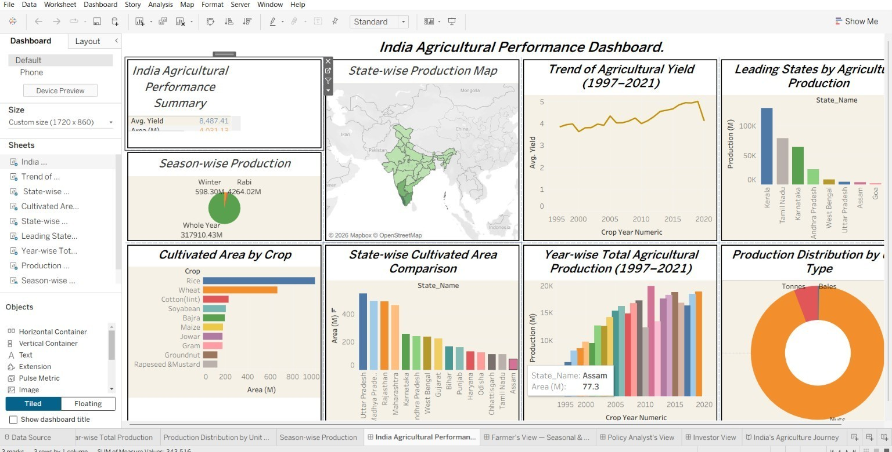

Dashboard 1 — India Agricultural Performance Dashboard (Overview)

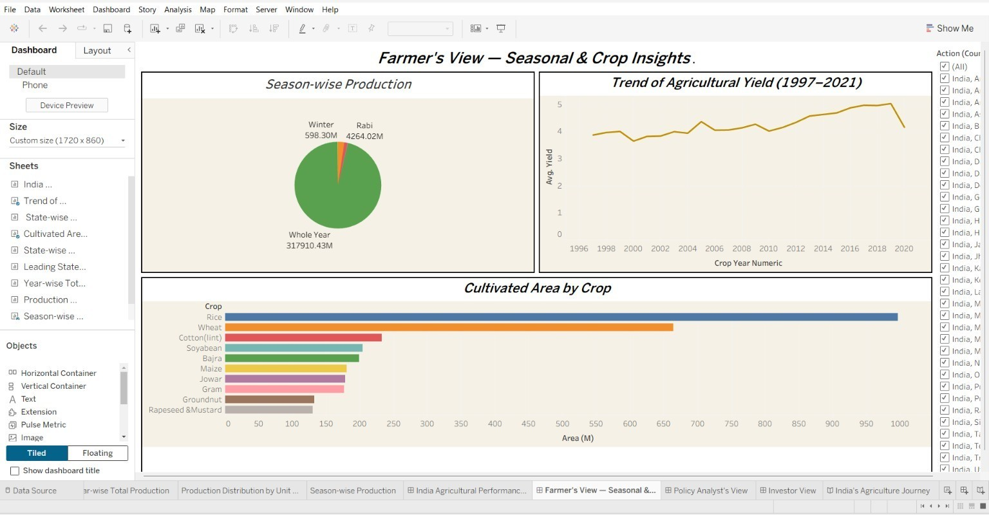
Dashboard 2 — Farmer's View — Seasonal & Crop Insights
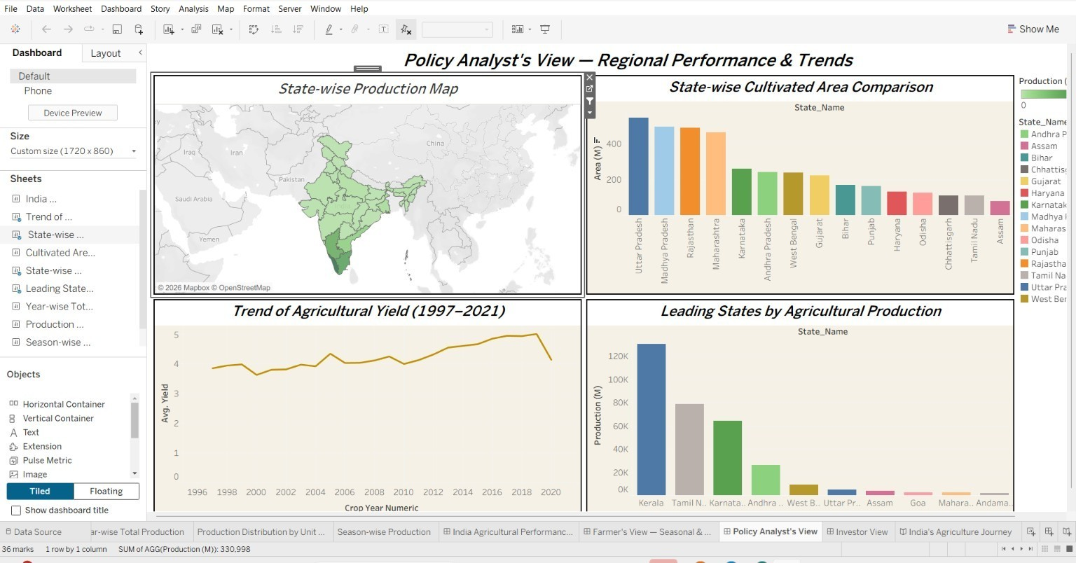

Dashboard 3 — Policy Analyst's View — Regional Performance & Trends

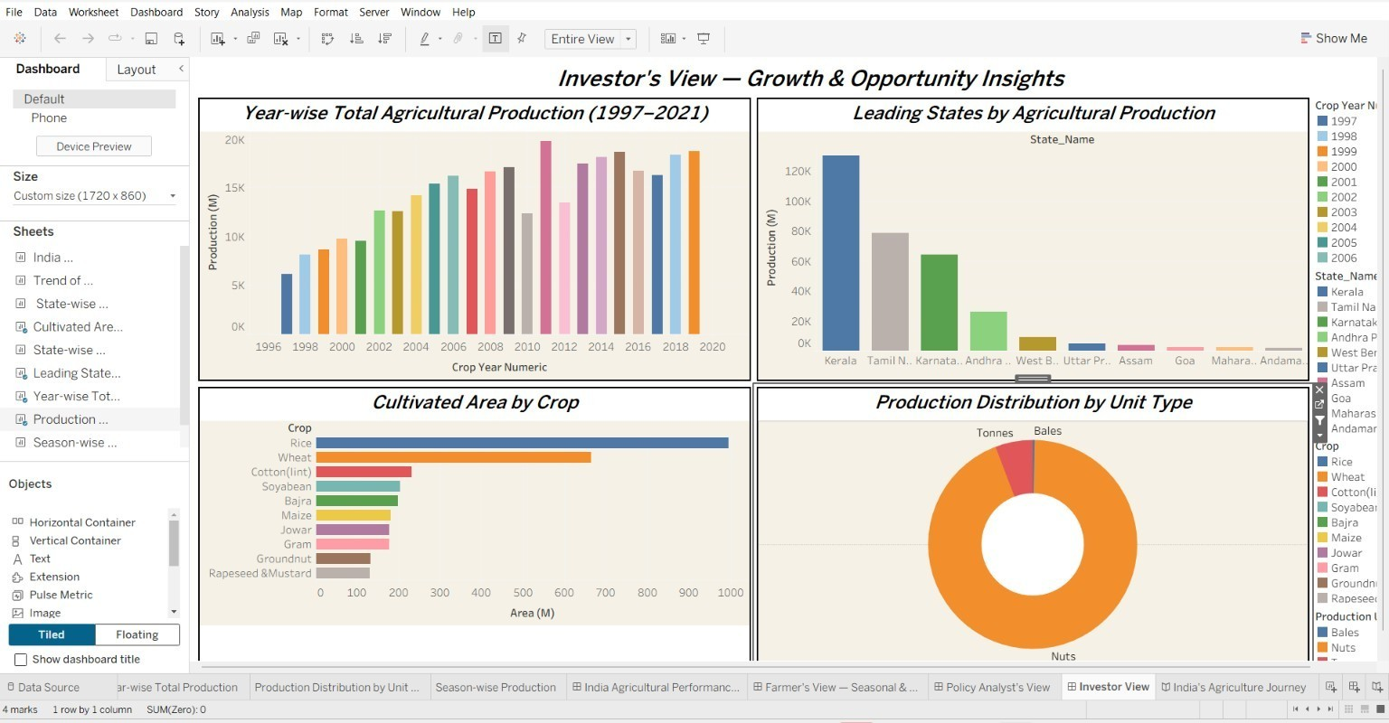

Dashboard 4 — Investor's View — Growth & Opportunity Insights

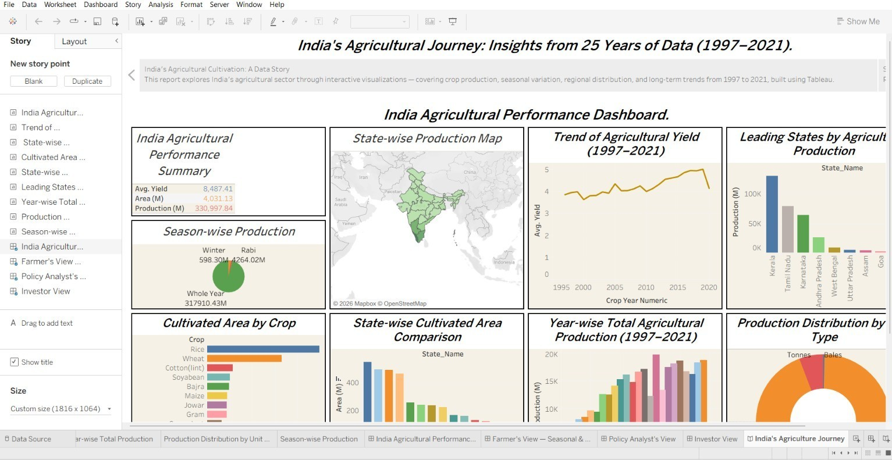

Story Point 1 — Overview

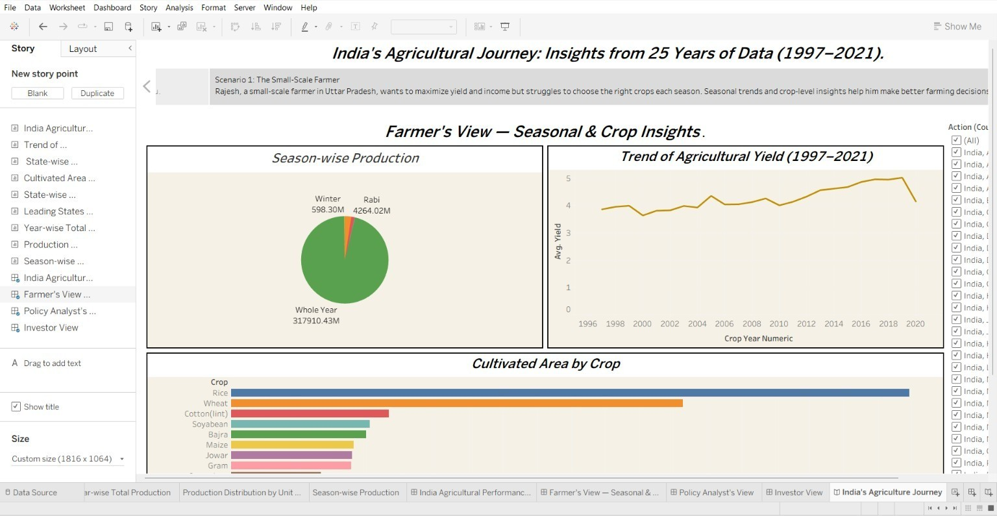

Story Point 2 — Scenario 1: The Small-Scale Farmer
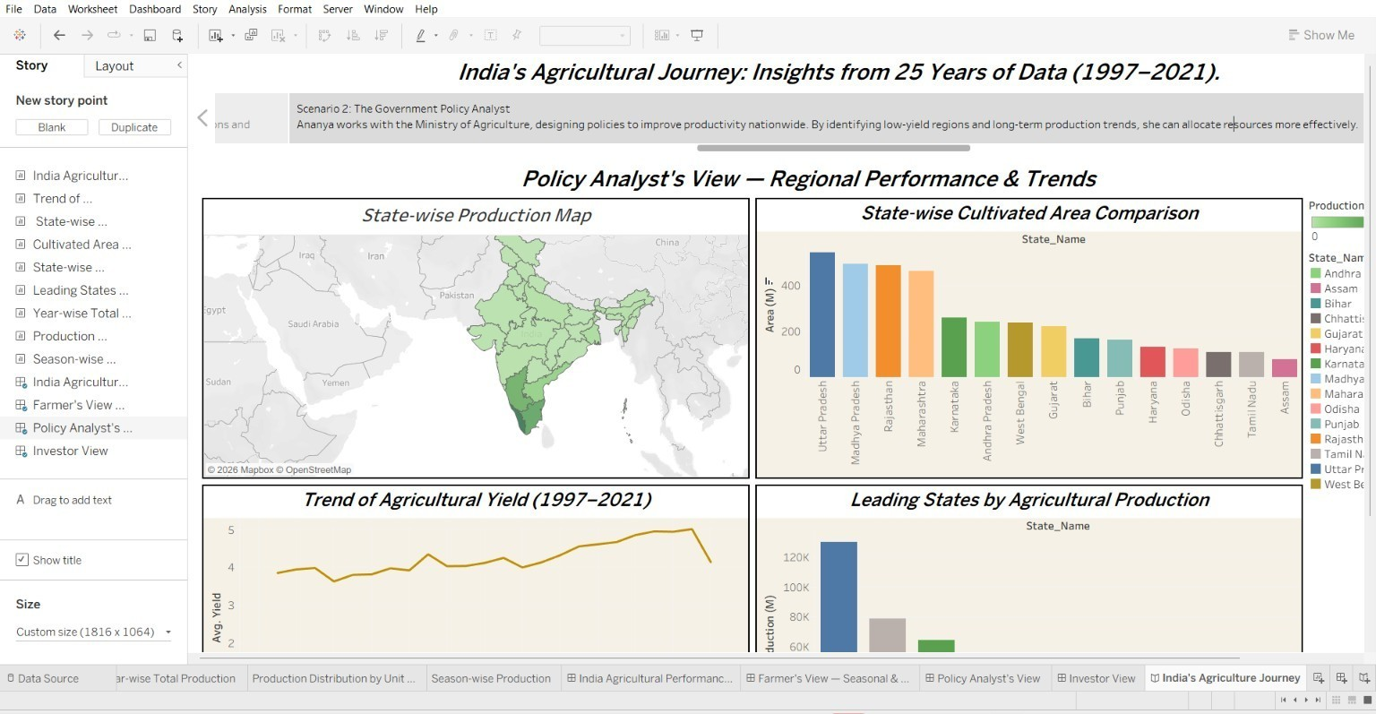

Story Point 3 — Scenario 2: The Government Policy Analyst

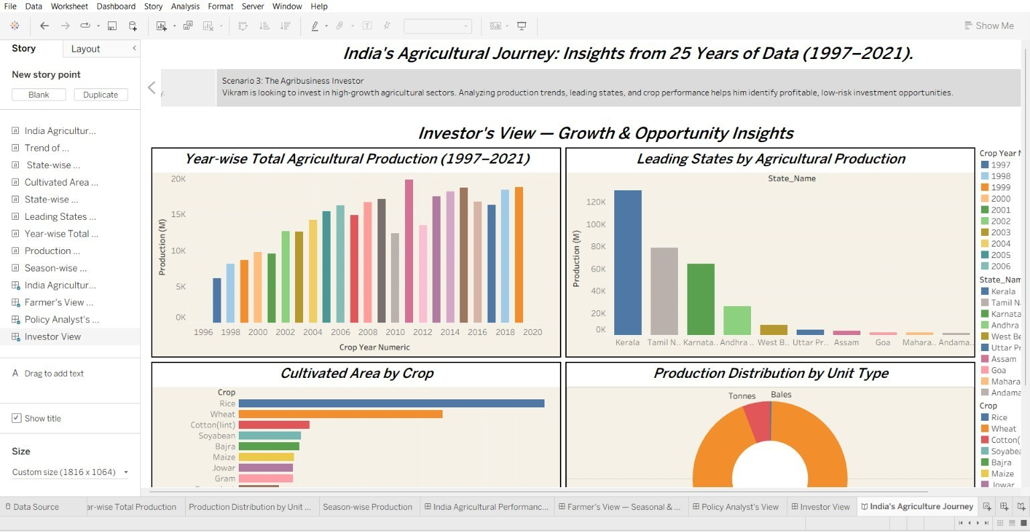
Story Point 4 — Scenario 3: The Agribusiness Investor
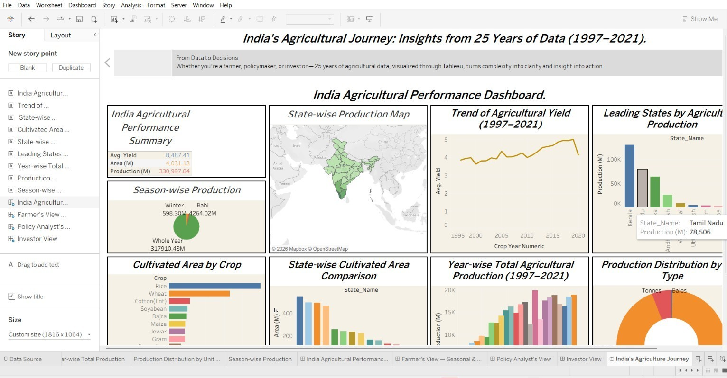
Story Point 5 — From Data to Decisions

8.Advantages & Disadvantages

Advantages
- Zero-cost deployment: every tool in the stack (Python, Tableau Public, GitHub) is free, with no server, license, or IT approval required.
- Role-specific dashboards mean each persona reaches a relevant view directly rather than filtering a generic report from scratch.
- Sub-3-second filter response on a 345,407-row dataset, confirmed by Performance Testing, with no extraction or aggregation needed.
- No login barrier: the public Tableau link is accessible on any browser, which matters for low-digital-literacy users like Rajesh.
- Cross-browser and mobile-view compatibility, validated in Chrome, Edge, and Safari.
- Clear traceability from persona pain points through requirements to shipped charts, keeping the workbook focused rather than feature-bloated.

Disadvantages
- 2021 figures are partial-year, since year-end government reporting was incomplete at the time of data collection — visible as a dip at the end of the yield trend line rather than an actual decline.
- Production_Units differ by crop (Tonnes, Bales, Nuts); raw production rankings can be misleading unless read alongside the Production Distribution by Unit Type chart.
- District-level data exists in the schema but was not used for district-level charts in this phase, limiting drilldown granularity for a farmer wanting hyper-local detail.
- Tableau Public workbooks are visible to anyone with the link, which is appropriate here since the dataset is public, but would not suit a project involving sensitive data.
- As a solo-built project, there was no second reviewer or QA pass beyond the documented Performance Testing, so edge cases outside the eight tested scenarios are not formally verified.

9.Conclusion

This project successfully converts 25 years of raw, unfiltered Indian government crop production data into an interactive, role-aware Tableau Public workbook. By tracing every chart back to a specific persona pain point identified during Ideation, and validating every functional and non-functional requirement during Performance Testing, the finished solution gives a farmer, a policy analyst, and an investor each a dashboard suited to their own decision — without requiring any of them to install software, log in, or interpret raw spreadsheet data. All eight performance test cases passed with no defects, and the workbook, cleaning scripts, and full documentation set are version-controlled and publicly available via GitHub and Tableau Public.

10.Future Scope

- Extend the dataset with post-2021 years as government reporting is finalised, refreshing the existing workbook without redesigning any dashboard.
- Add district-level drill-down charts using the District_Name field already present in the schema but currently unused.
- Blend in rainfall and Minimum Support Price (MSP) data as new calculated fields to build a rainfall-adjusted yield metric and a price-vs-production view for investors.
- Introduce a farmer feedback loop to track whether data-informed crop choices actually improved outcomes across subsequent seasons.
- Migrate from Tableau Public to Tableau Server or Tableau Cloud if the project moves from an individual capstone to an institutional or government-hosted deployment, enabling authenticated, higher-frequency data refreshes.

11. Appendix

Source Code
The Python (Pandas) preprocessing scripts used to clean and enrich the raw government extract into skillwallet_crop_cleaned.csv are maintained in the GitHub repository listed below.

Dataset Link
Historical Indian Crop Production Data, 1997–2021 (government agricultural statistics) — cleaned extract: skillwallet_crop_cleaned.csv, 345,407 rows, 12 columns, covering 36 states/union territories, 57 crop types, and 6 growing seasons.

GitHub & Project Demo Link
- Tableau Public workbook (all dashboards + Story):
https://public.tableau.com/app/profile/divya.kauluri/viz/IndiaAgricultureanalysisproject/IndiasAgricultureJourney?publish=yes
- GitHub repository (cleaning scripts + documentation):
https://github.com/divyakauluri-spec/India-sagricultural-crop-production-analysis

